**Ramrao Adik Institute of Technology**

**(Department of Computer Engineering)**



**Mini Project Report**

**On**

**Tesseract :Creation and Rotation using Blender**

**Subject-: Computer Graphics Laboratory**

***Presented By***

|  |  |  |
| --- | --- | --- |
| Roll No | Batch-Sr. No | Name |
|  |  |  |
| **16CE1027** | ***A2-13*** | **Shubham Jadhav** |
| **16CE1093** | ***A2-14*** | **Suchit Jadhav** |
| **16CE1070** | ***A2-15*** | **Jerin Thomas** |

**Signature of Internal Examiner**

**Contents of Report**

**Chapter 1-Introduction**

Blender is the free and open source 3D creation suite. It supports the entirety of the 3D pipeline- modeling, rigging, animation, simulation, rendering, compositing and motion tracking, even video editing and game creation. Advanced users employ Blender’s API for Python scripting to customize the application and write specialized tools; often these are included in Blender’s future releases. Blender is well suited to individuals and small studios who benefit from its unified pipeline and responsive development process.

Blender is cross-platform and runs equally well on Linux, Windows, and Macintosh computers. Its interface uses OpenGL to provide a consistent experience.

As a community-driven project under the GNU General Public License (GPL) the public is empowered to make small and large changes to the code base, which leads to new features, responsive bug fixes, and better usability. Blender has no price tag, but you can invest, participate, and help to advance a powerful collaborative tool: Blender.

In this project, we have made an animation video of 4-DIMENSIONAL HYPERCUBE (TESSERACT) using blender software. We have first made the Hypercube using a CUBE Mesh and added coloured materials to it. Then we have made a base using a plane and the backside plane has a texture as mirror resulting in a mirror behind our animation.

Then we have deleted all the faces of cube and gave the cube a wireframe modifier.

We have aligned the objects in desired configurations and animated all the objects in different key frames by inserting different keys.

The camera has also been kept at an specific position to capture different angle of animation.

The animation displays a Cube in 4th dimension i.e. A Tesseract rotating in a imaginary 4th dimension. This animation gives us a view of how Tesseract will look in 3-Dimension while rotating in 4th Dimension.

To produce an image like the one above involves two major steps to start with:

* **Modelling**, which is the creation of your miniature 3D world, also known as a **model** or **scene**. This involves defining the geometry of the objects, making it look like they are made out of particular **materials**, setting up the **lighting**, and defining a **camera** viewpoint.
* **Rendering**, which is the actual generation of the image of the world from the viewpoint of the camera (taking a “photograph” of the scene, if you like), for your audience to enjoy.

3D is often used to produce not just single still images, but **animations** as well. This requires some additional steps:

* **Rigging** — setting up a **rig**, namely a way of **deforming** (changing the shape of) a character in various repeatable ways to convincingly mimic joint movements, facial expressions and other such actions of real-life people or animals.
* **Posing** — choreographing the positions of the objects and their parts in the 3D scene over time, using the previously-created animation rigs
* Rendering now involves creating a whole **sequence** of frames representing movement over time, rather than just a single still frame.

But that’s not all. There are frequently additional processes to embellish the results of the above, to make them look more realistic:

* **Sculpting** — a more organic form of modelling objects by shaping them as though they were made out of clay. This produces more complicated, irregular shapes which mimic real objects found in nature, as opposed to clean, simple, geometrical ones which mostly only exist in the world of mathematics.
* **Texture painting** — You’re probably familiar with programs that let you paint an image on a 2D digital canvas. Such programs are commonly used in 3D production, to create **textures** which are “wrapped” around the surfaces of 3D objects to give them a more interesting appearance. 3D programs also often allow direct painting on the surfaces of those objects, so the effect of the design can be observed immediately, instead of having to go through a separate paint-on-a-flat-surface-then-wrap sequence of steps.
* **Physical modelling** — simulating the behaviour of real-world objects subject to real-world forces, for example hard balls colliding, soft cloth draping itself over an obstacle under gravity, water flowing and pouring. Mathematical formulas are available for these that give results very close to real life, all you need is the computing power to calculate them.
* **Motion capture**, or **mocap**: producing convincing animations, particularly ones that look like the movements of real people (walking, running, dancing etc) can be hard. Hence the technique of capturing the motions of live actors, by filming them with special markers attached to strategic points on their bodies, and doing computer processing to track the movements of these markers and convert them to corresponding movements of an animation rig.
* **Compositing** — this is where 3D renders are merged together with real photographic/live-action footage, to make it look like a rendered model is in the middle of a real-world scene, or conversely a real live actor is in the middle of a rendered scene. If done with proper skill, in particular due care to matching the effects of lights and shadows, the viewer becomes unable to tell what is real and what is not!

**Chapter-2 Implementation**

Blender Version 2.79

STEPS-

1. Press Shift+A to add CUBE. Add materials to it
2. Go to edit mode and delete all the faces of the cube.
3. Duplicate the cube and scale it with factor of 2.
4. Go to edit mode and press Z.
5. The small cube should be inside of the bigger cube.
6. Now join the vertices of both cubes by selecting by Shift and Pressing J.
7. Create faces between the quads of vertices by selecting by Shift and Pressing J.
8. Now select the whole structure and apply the wireframe from Modifiers.
9. Add hooks to all the vertices of both cubes by Ctrl+H.
10. We now select the wireframe and add thickness to it in settings.
11. For animation, change screen layout to animation. Create end frame as 60th frame. Now on the first frame.
12. Select all the 16 hooks by Shift and save their location by pressing i and then click on location.
13. Now proceed to 60th frame and change the location of each hook to the respective position by G and save the location of all 16 hooks by pressing i and then click on location.
14. We place the camera at the desired position by G.
15. We now add a plane by Shift+A and click on Plane.
16. Place the place the plane below the structure.
17. Duplicate the plane and place it behind the tesseract and in-front of camera.
18. Click on the last plane and change the texture to mirror.

**Chapter-3 Screenshots**

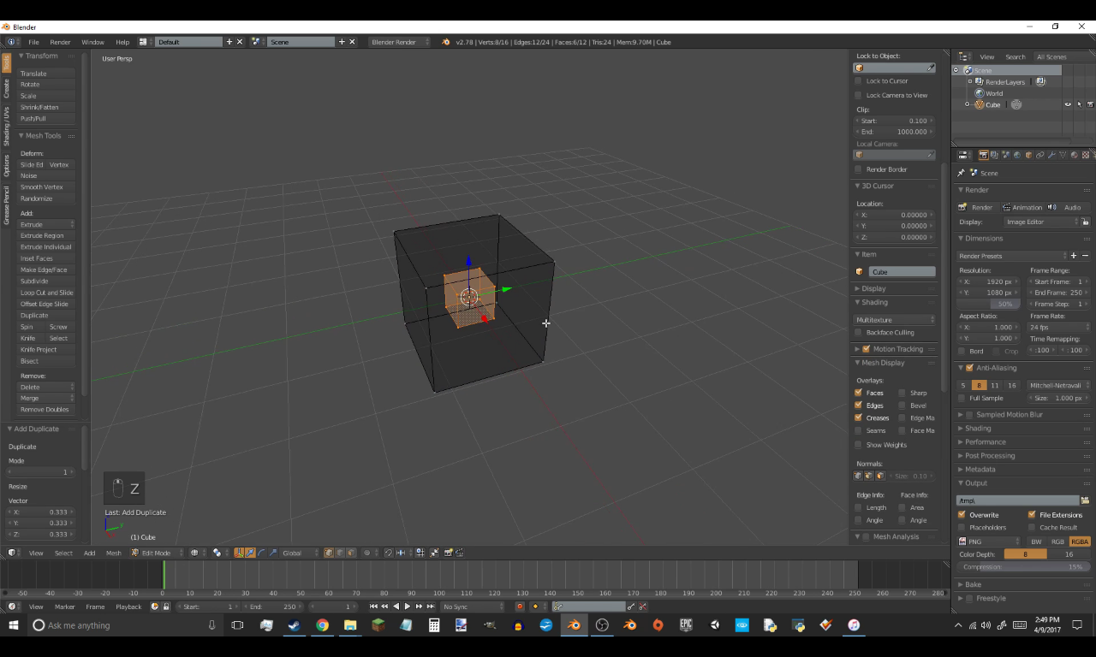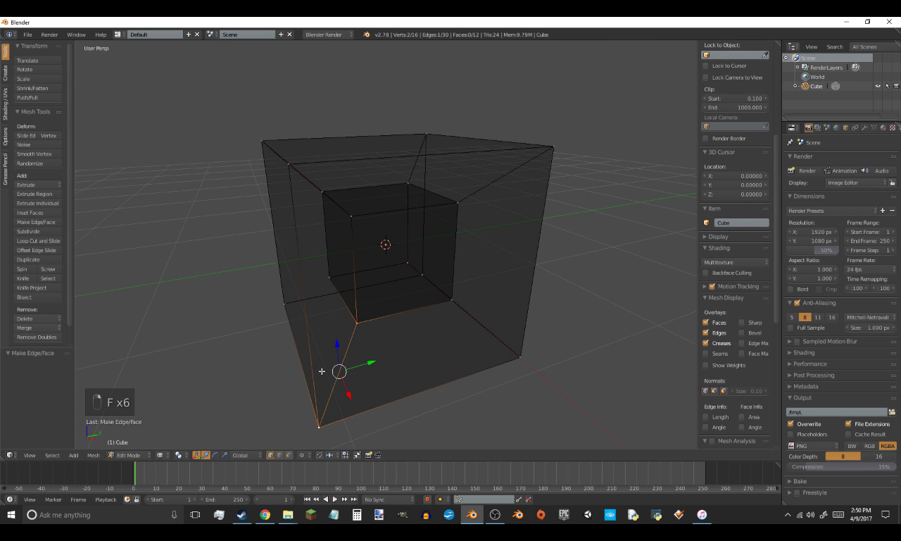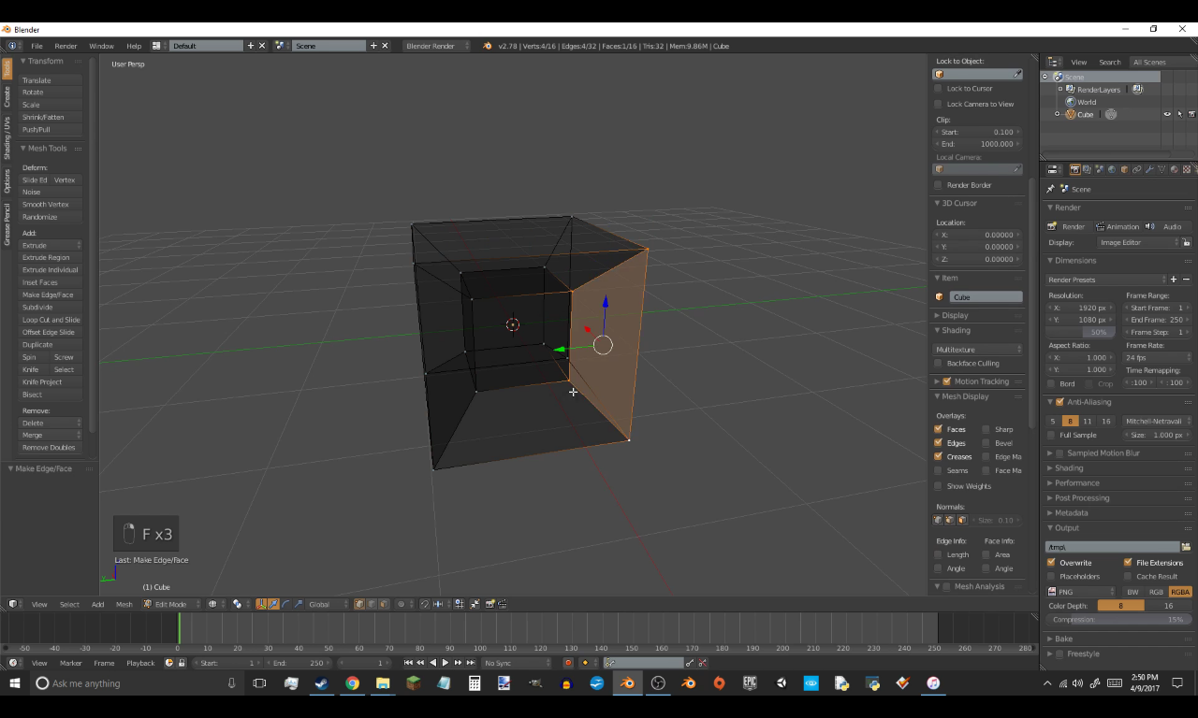 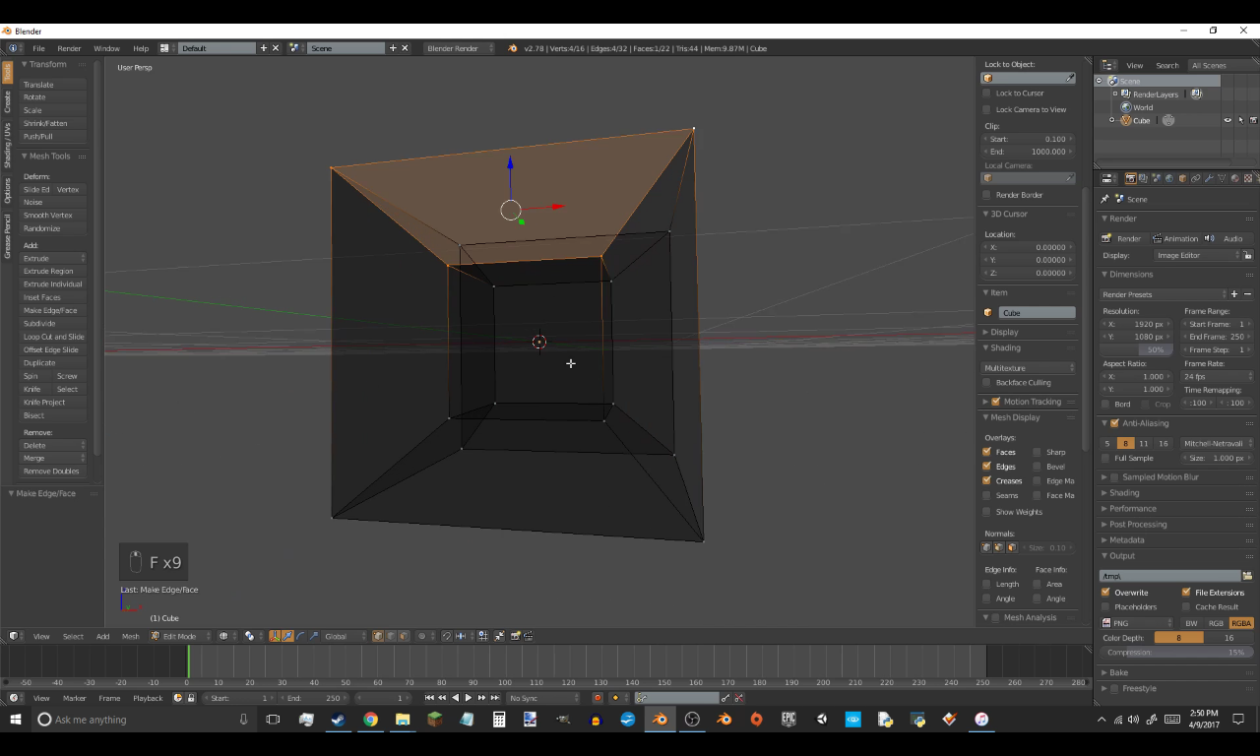 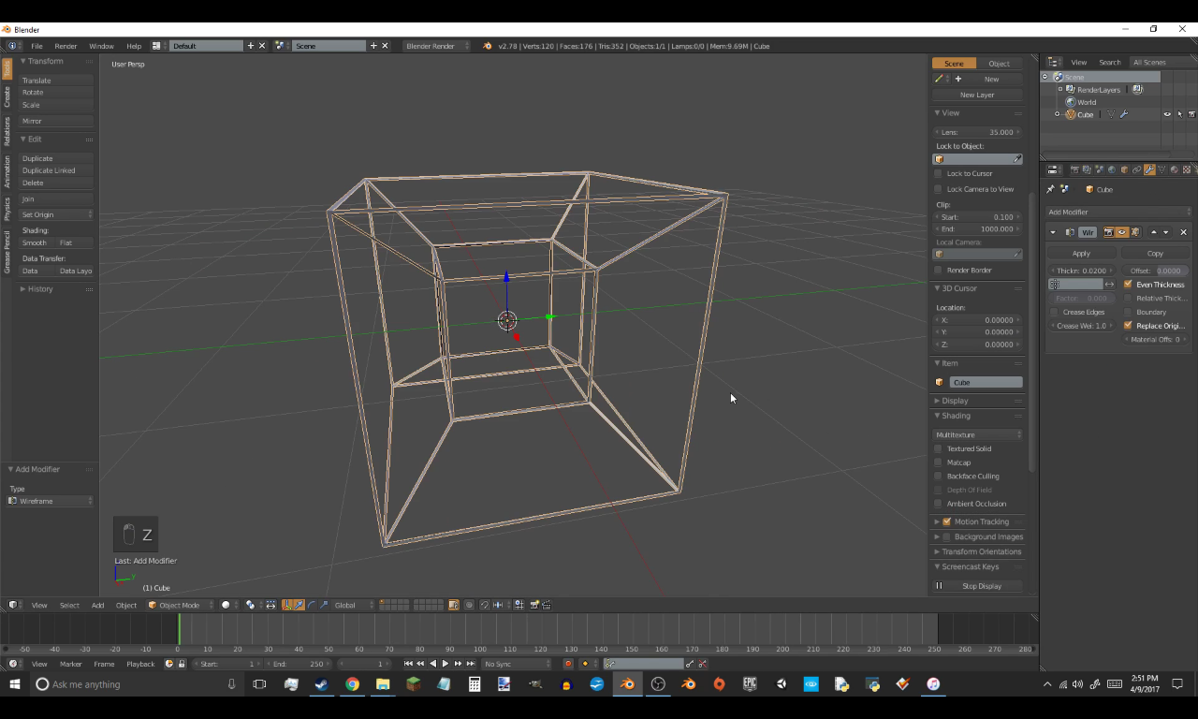 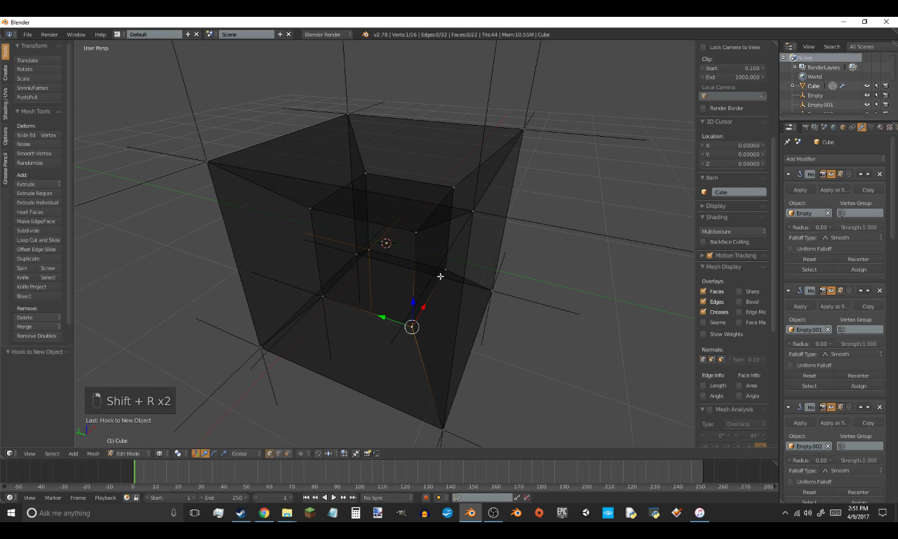 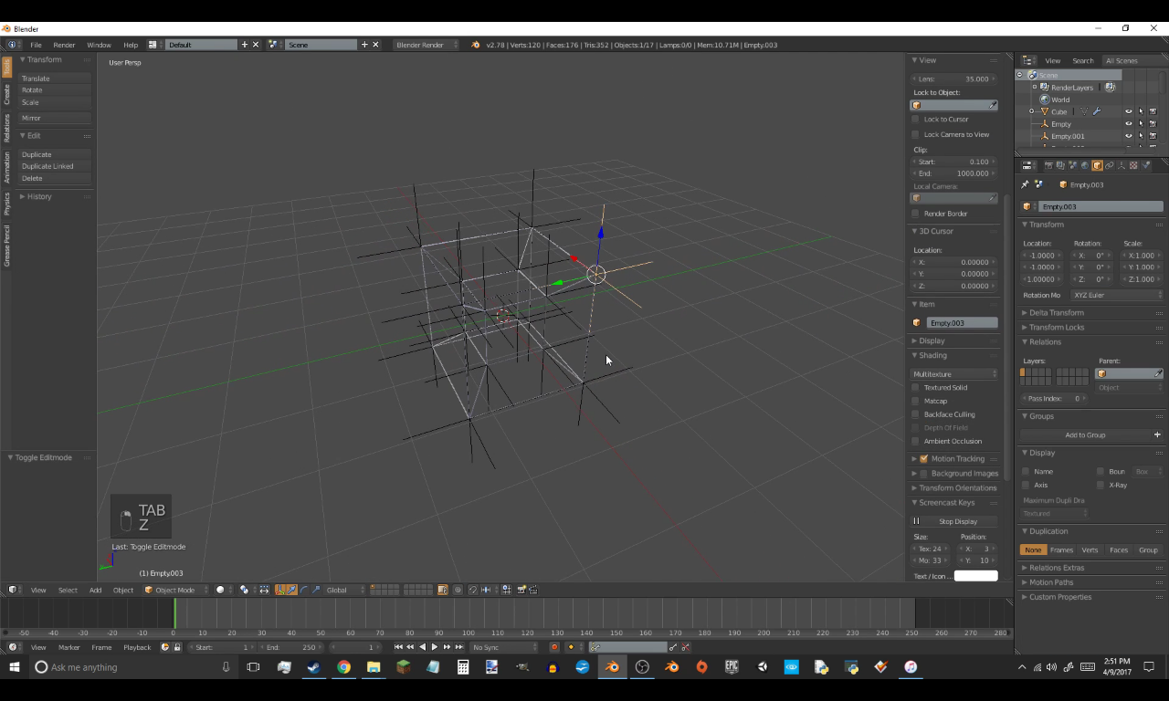 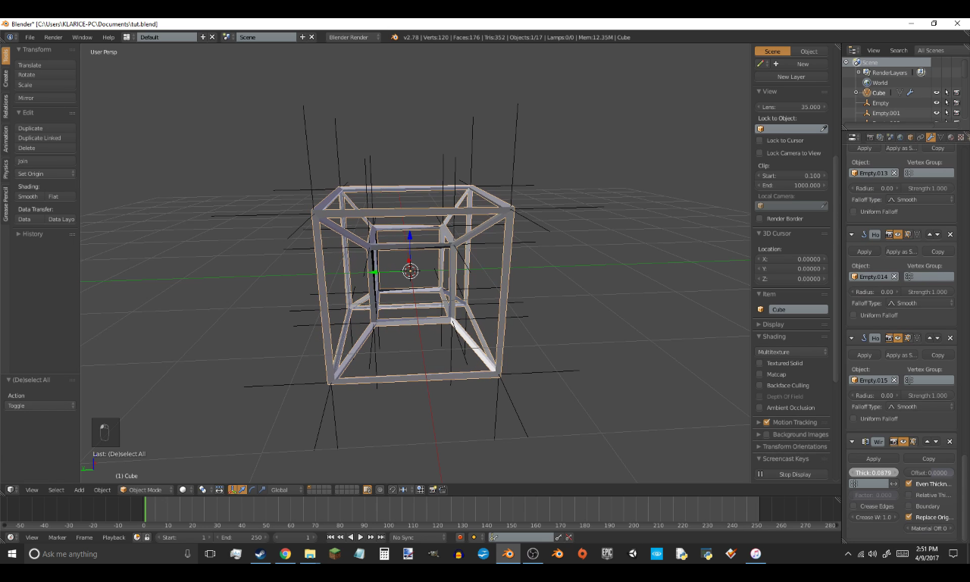 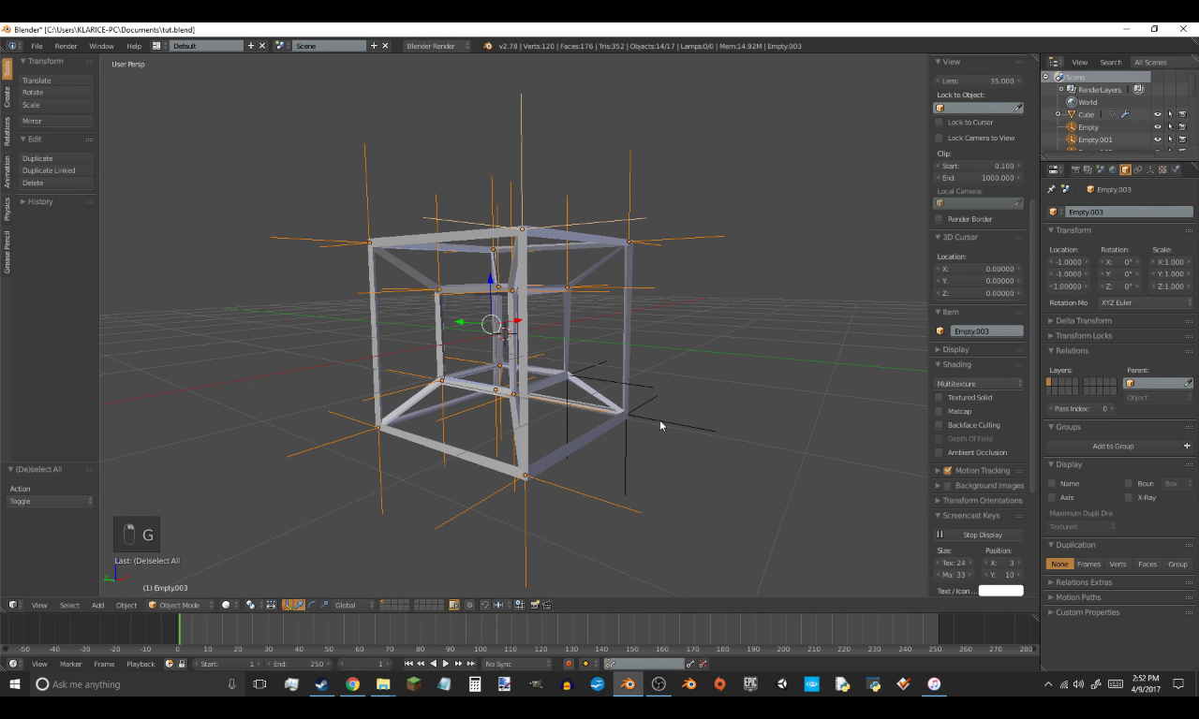 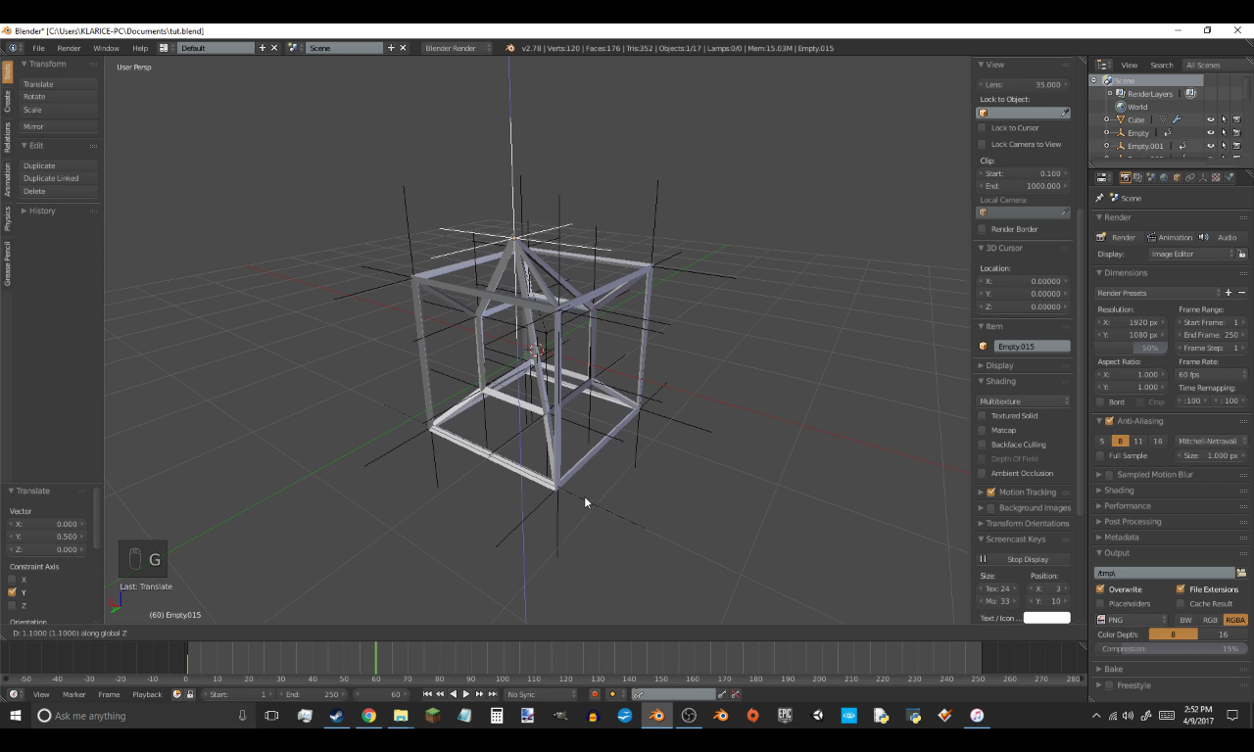 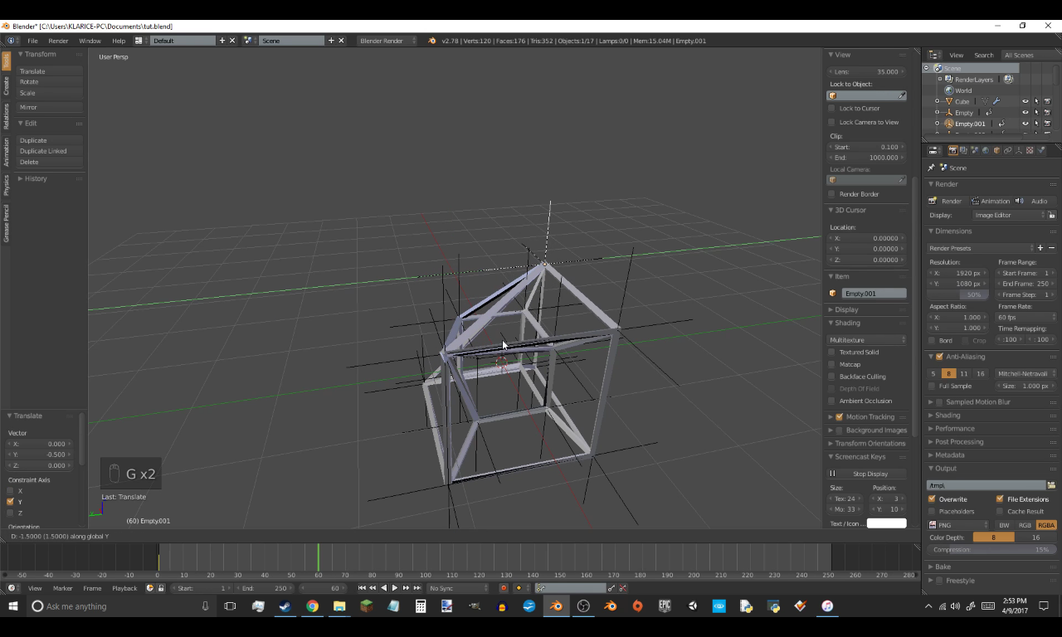 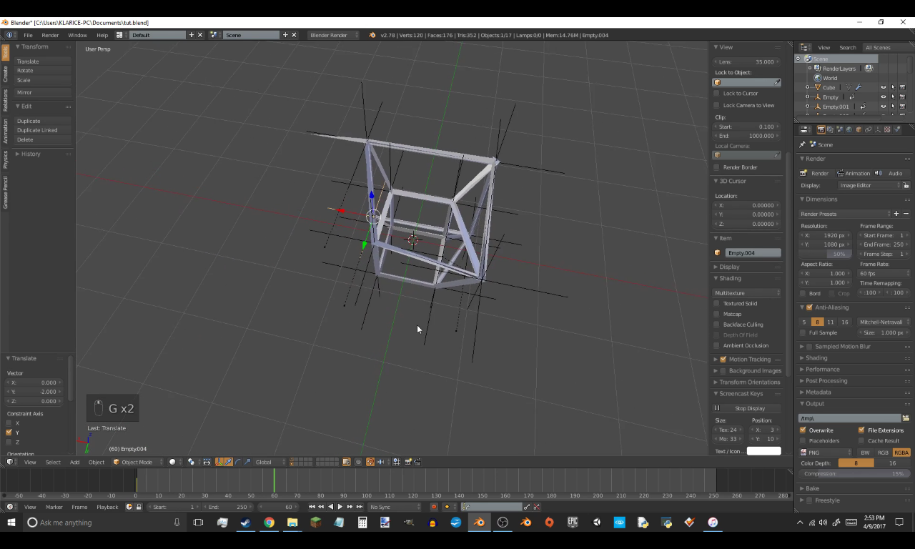 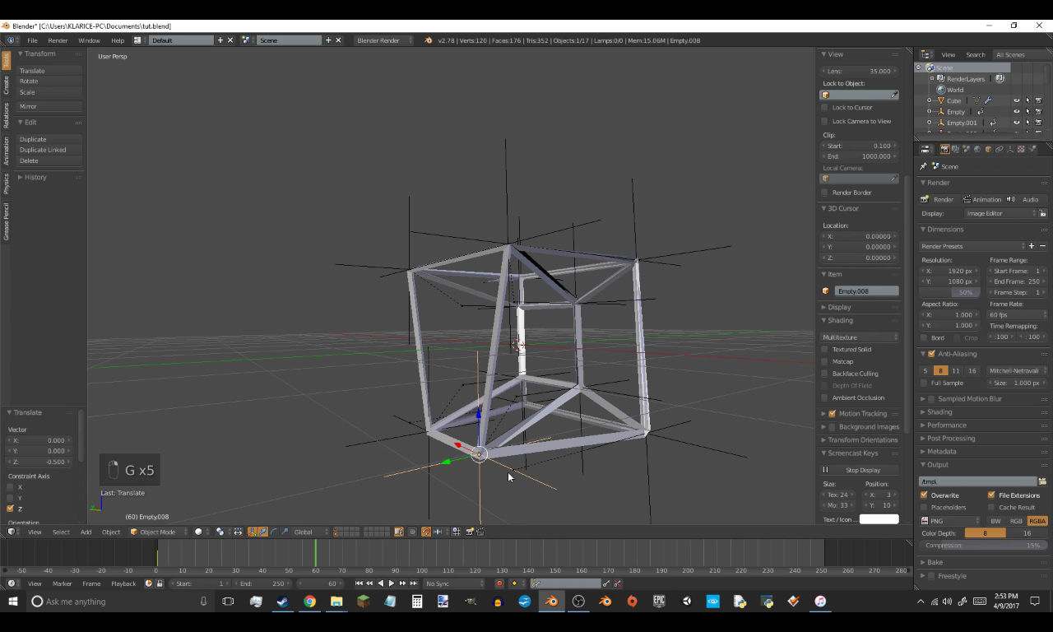 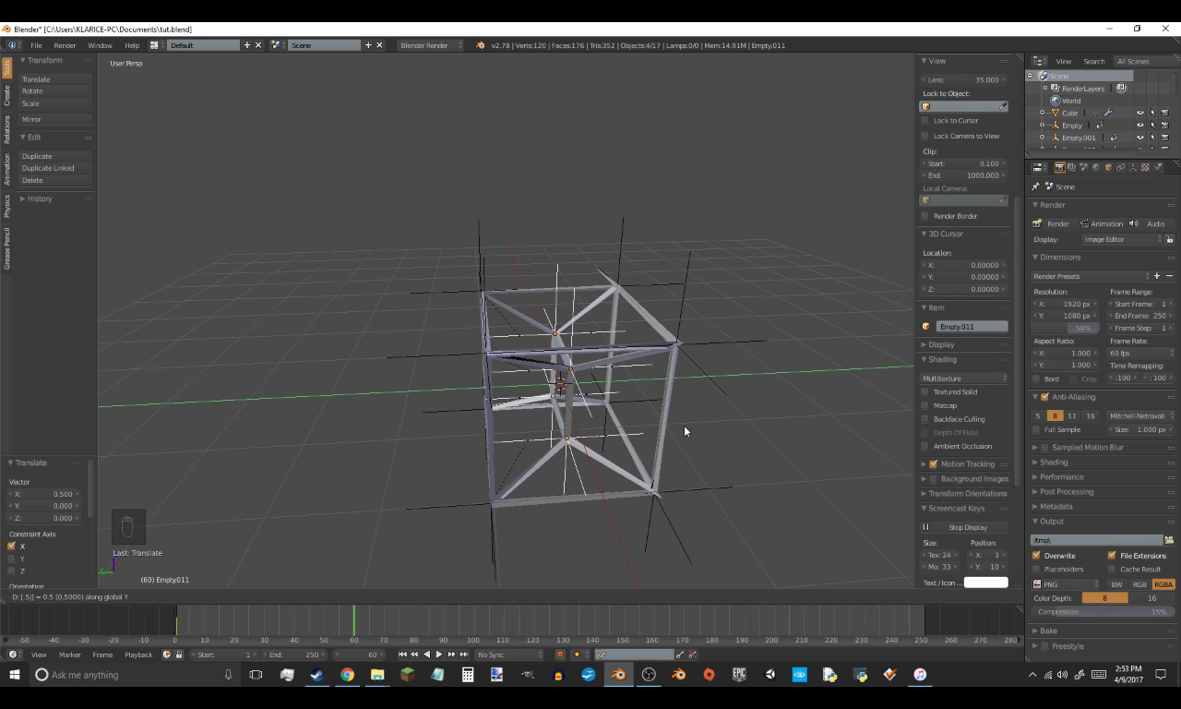 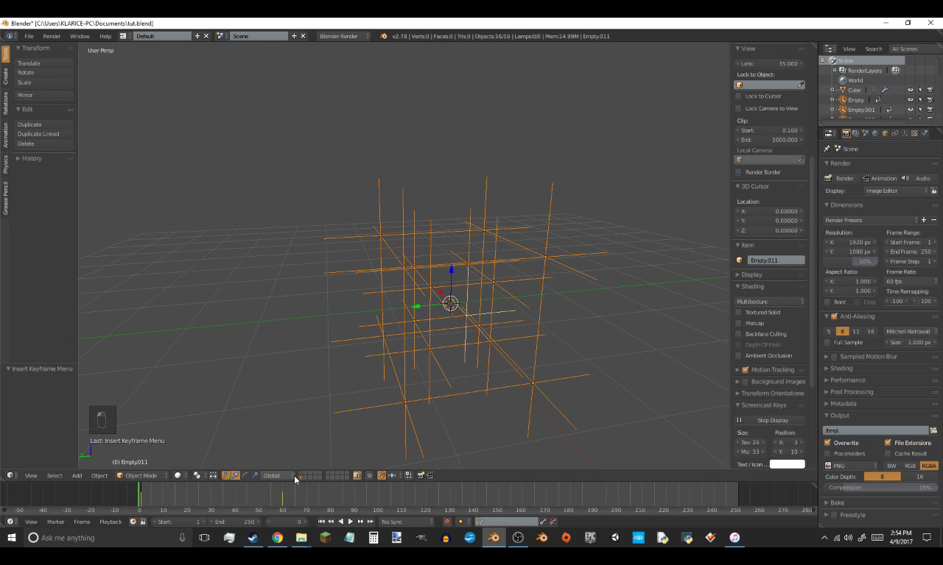 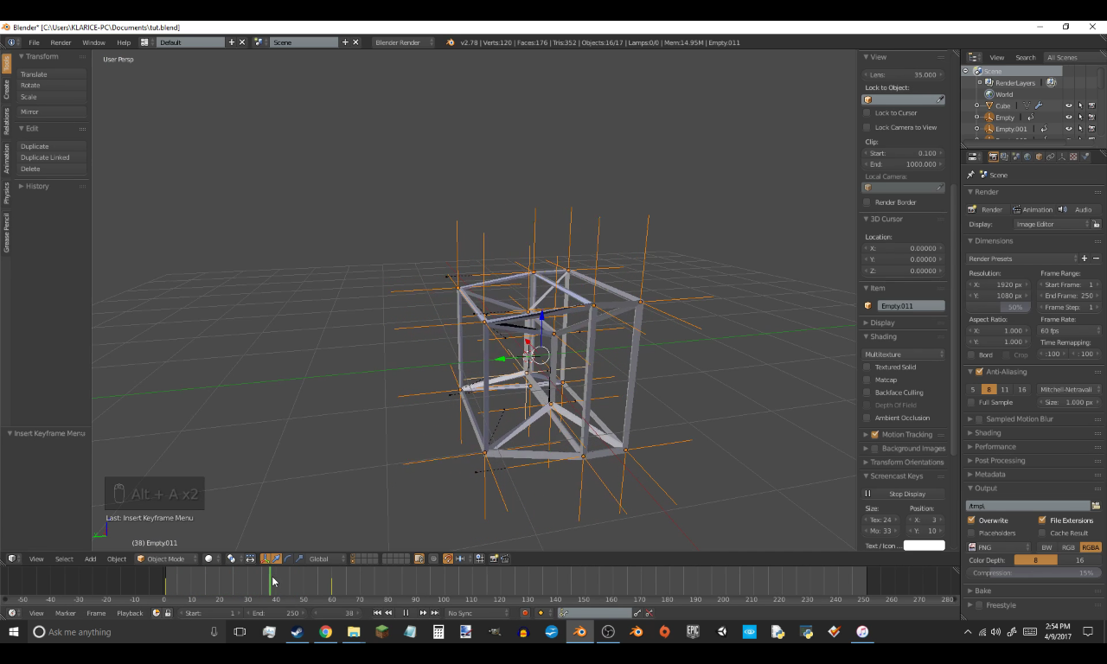 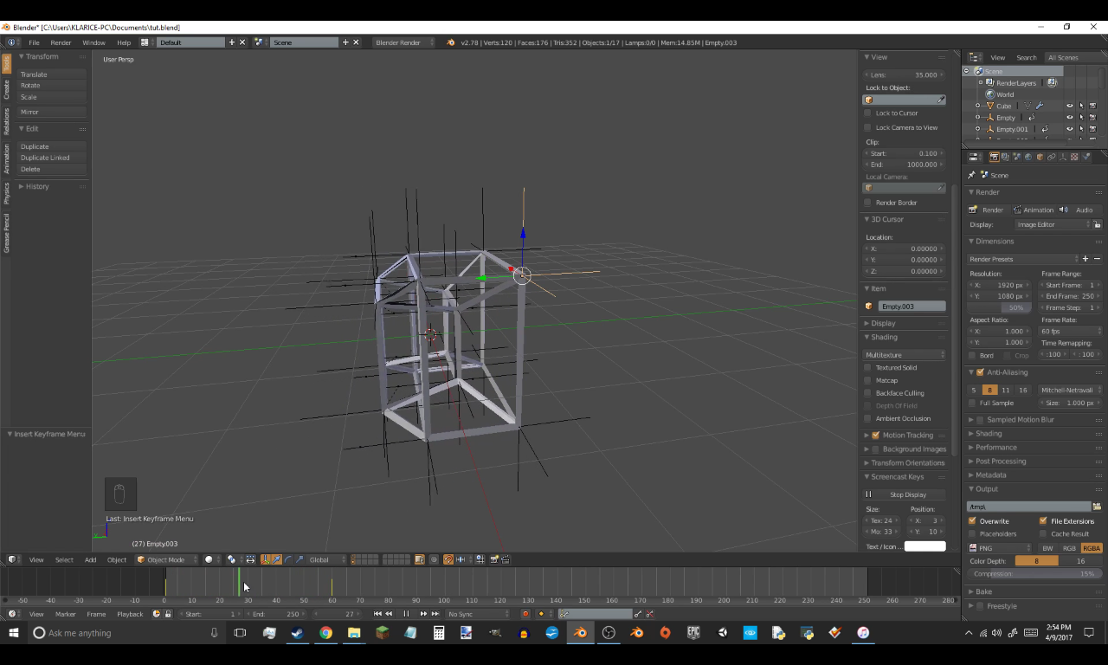 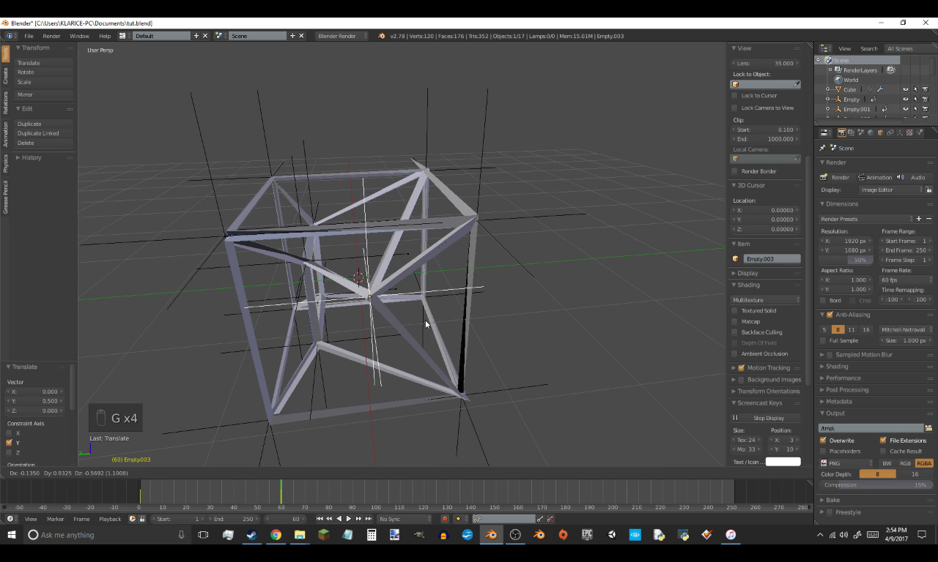 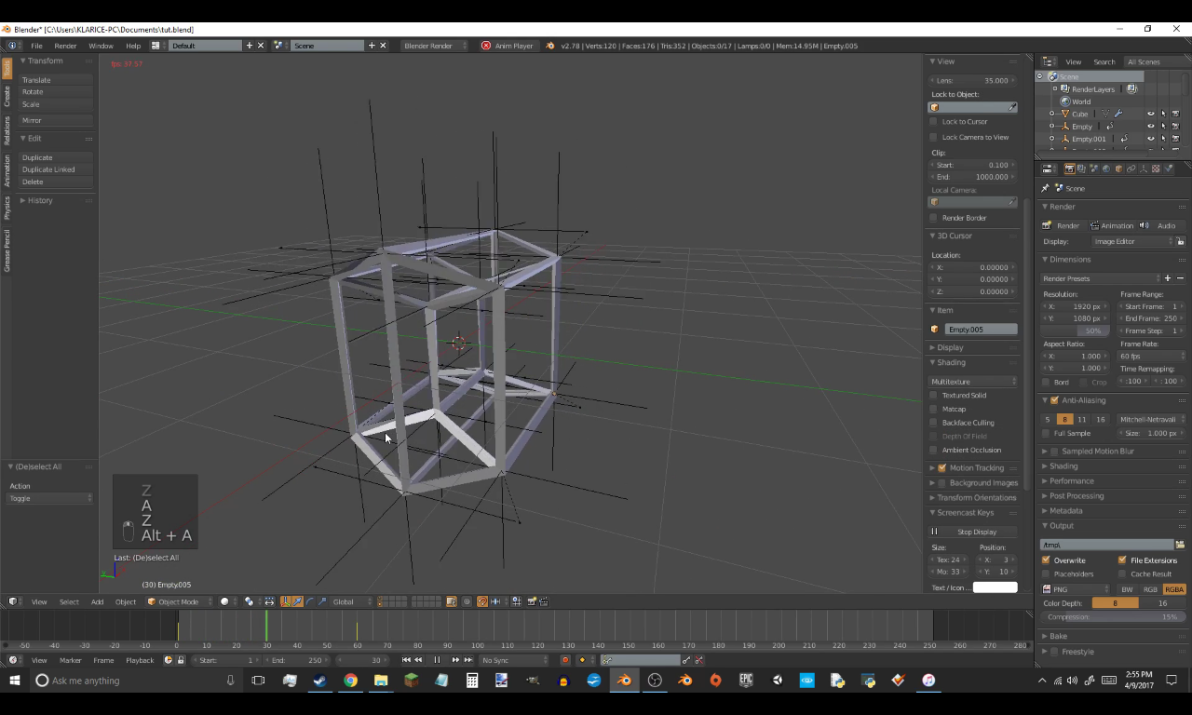 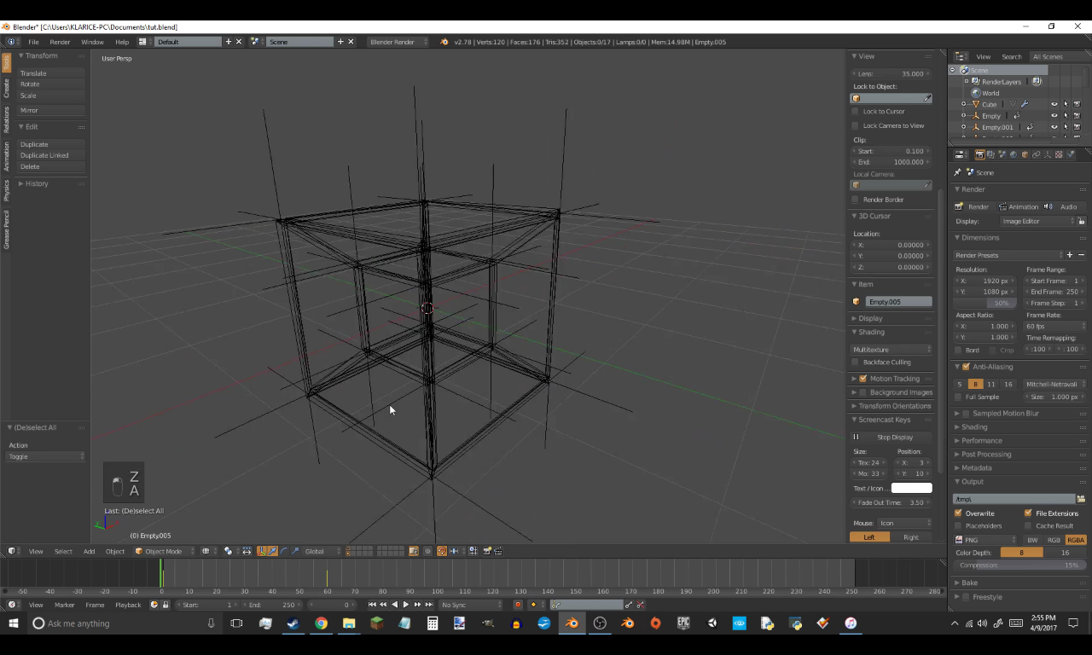 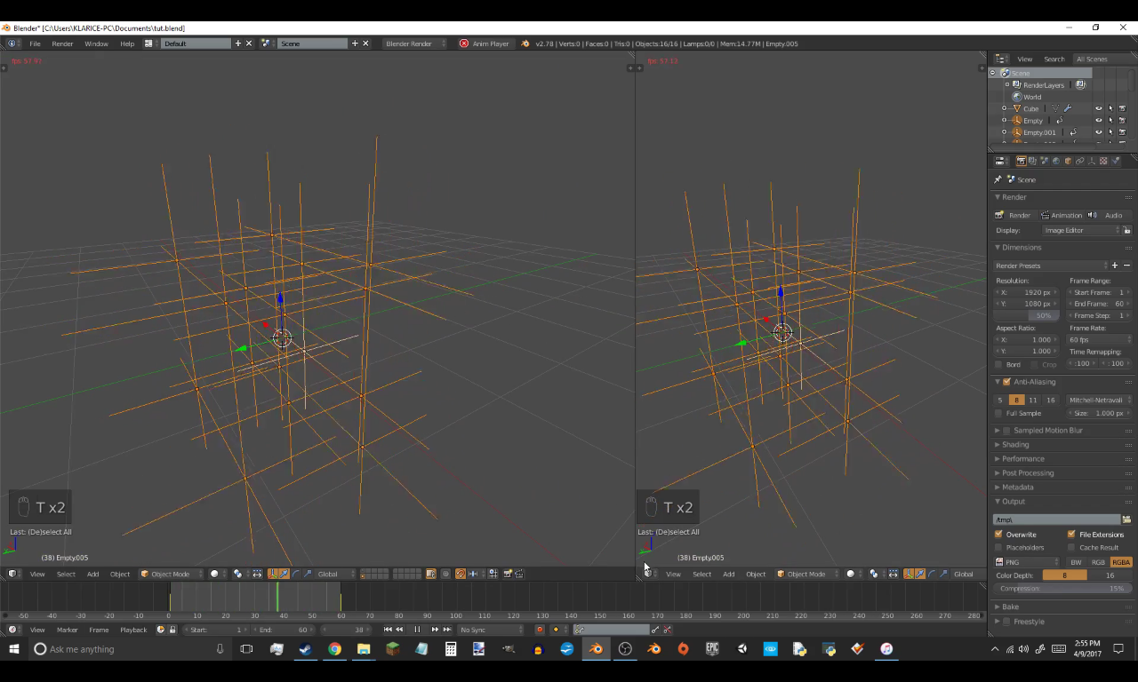 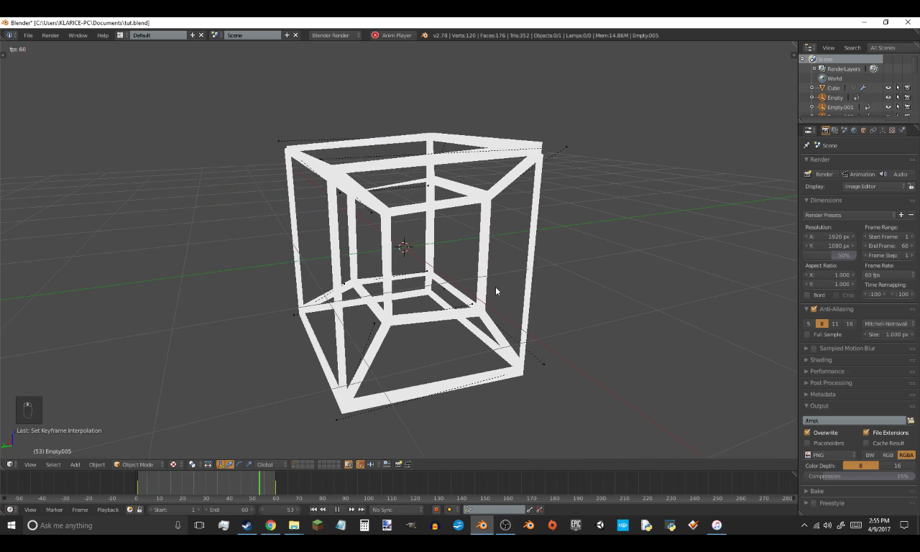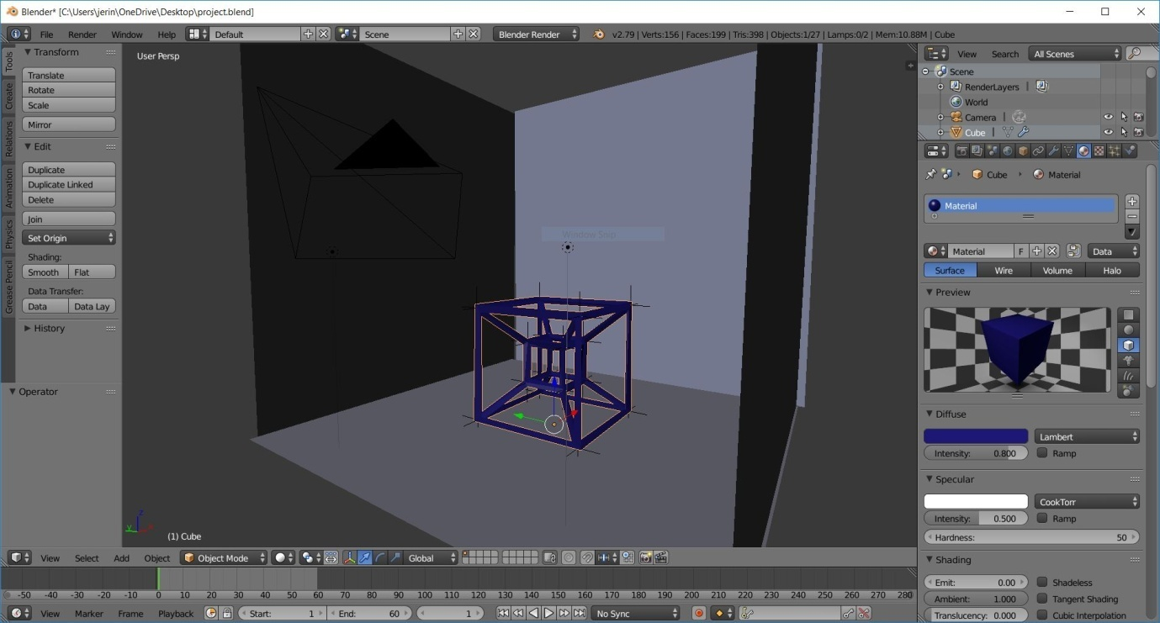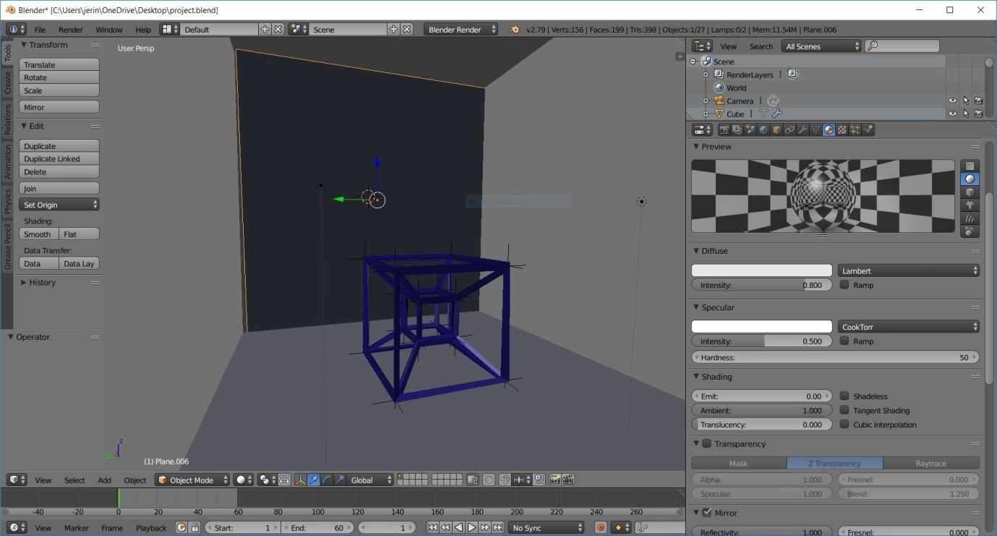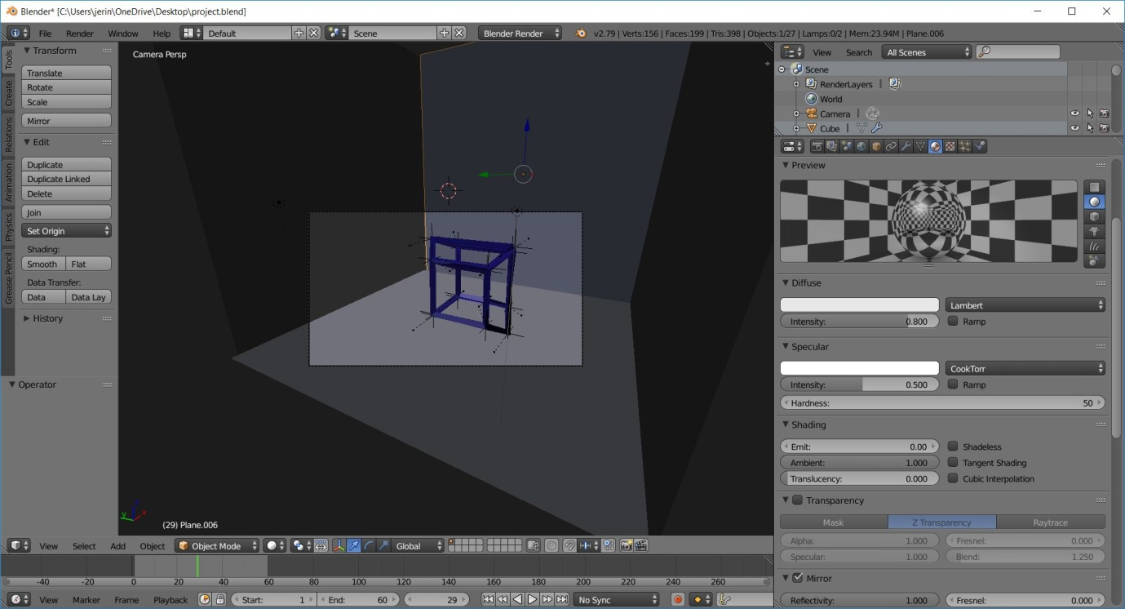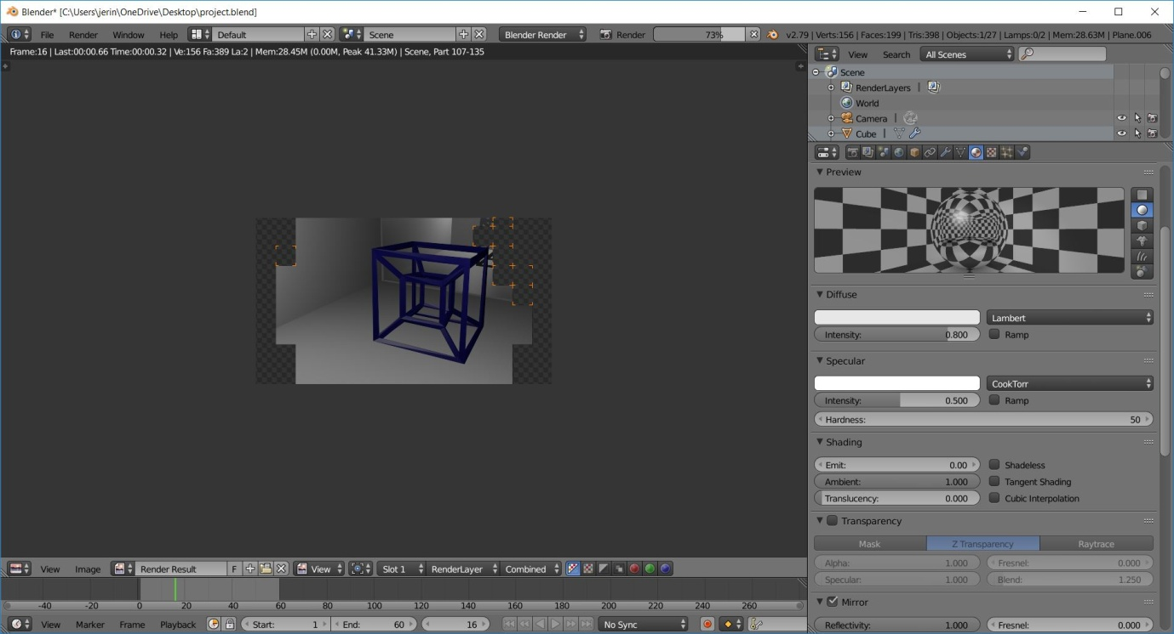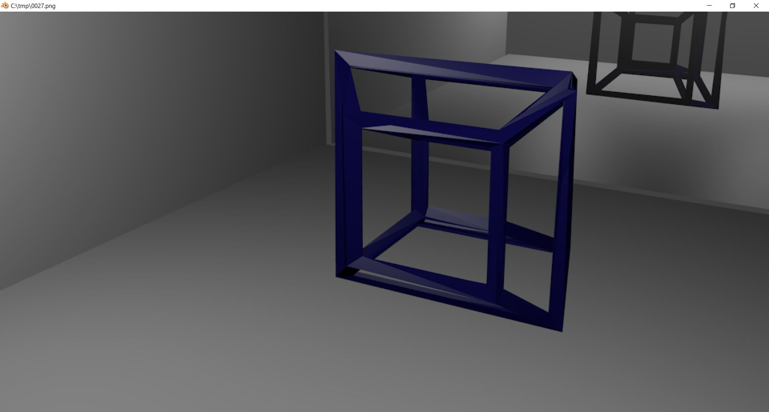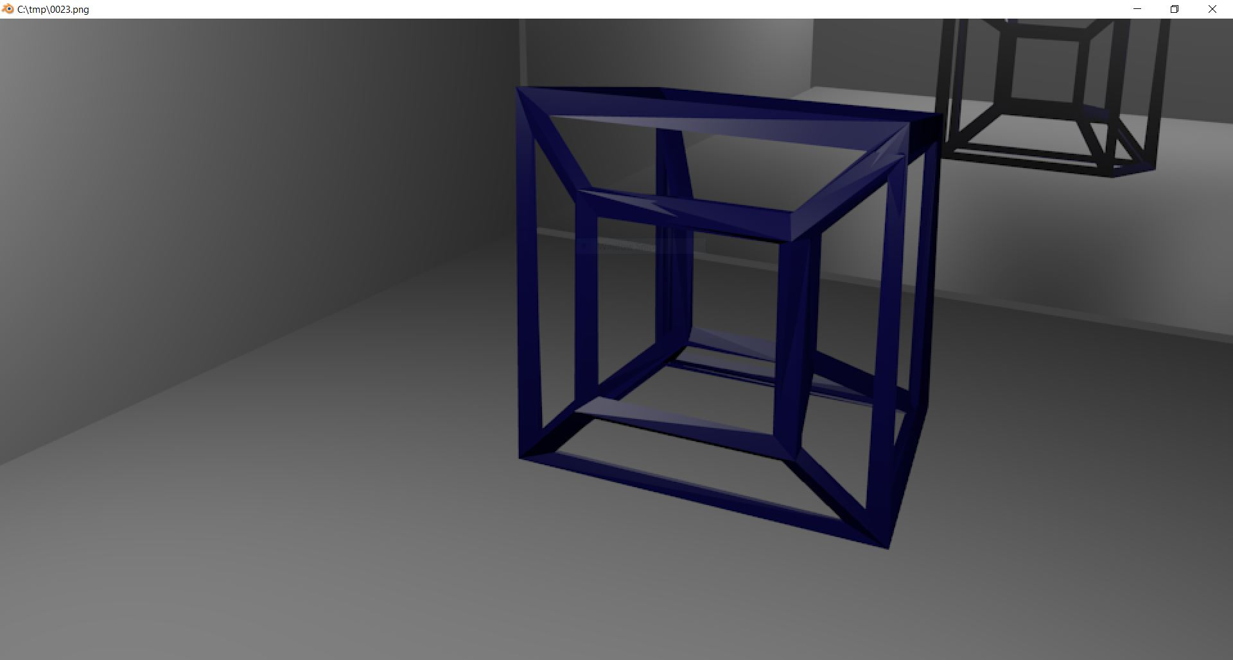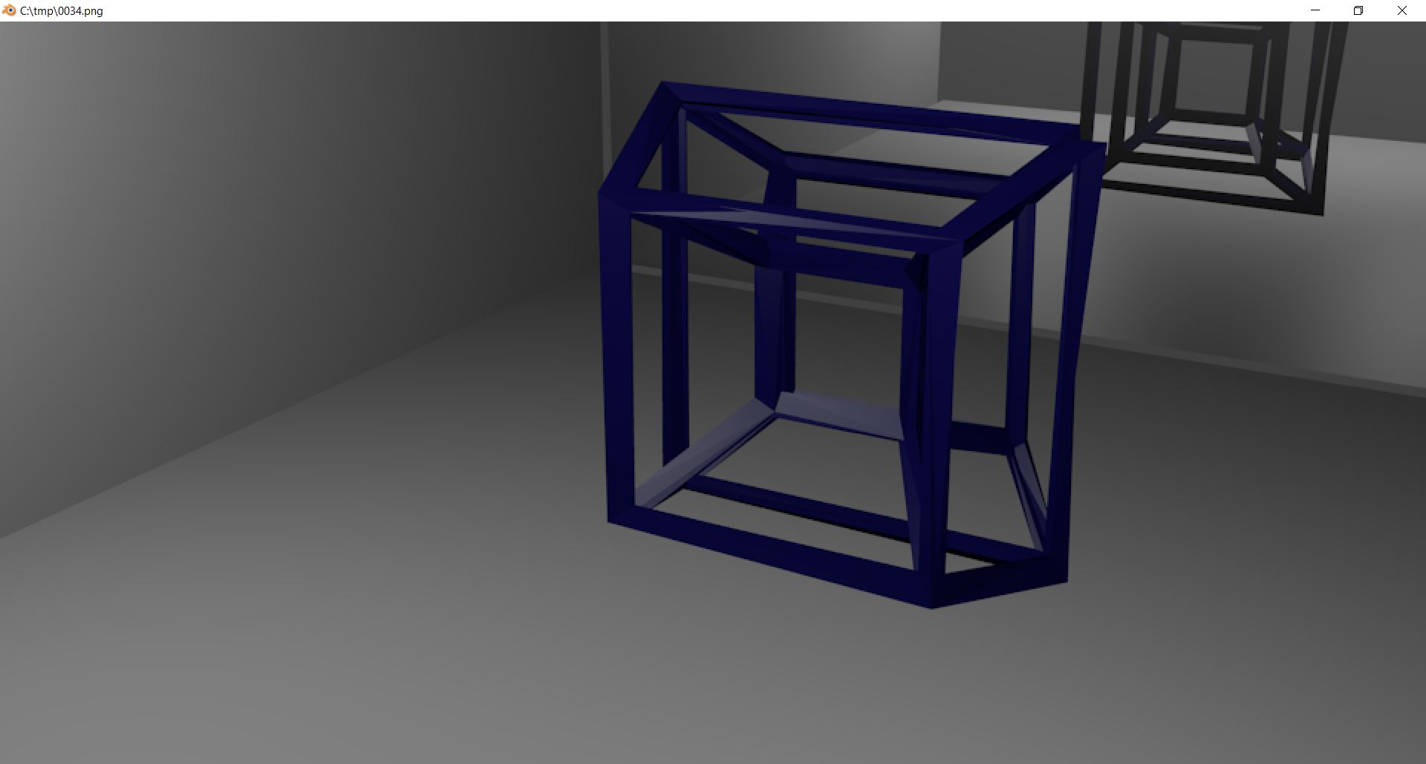

**Chapter-4 Conclusion**

Thus , we have used the Blender Software to create the Tesseract animation.